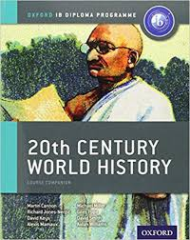
IB World History HL 11 – Summer Assignment (2022 – 2023)

All work will be posted on Google Classroom. Join the class IB World 11 HL – code: qewh57f. A series of readings with question responses and a link to a video will be posted. All work will be completed and submitted on Google Classroom by the FIRST DAY OF CLASS

Activity 1 – Read Chapters 1,2 and 3 from the book, A Short History of the 20th Century by Geoffrey Blainey. Answer the questions for each chapter. Questions should be answered using complete sentences

Activity 2 – Read the Journal article – The rivalry of Germany and England and answer the questions. Questions should be answered using complete sentences

Activity 3 – Watch the Video – Age of Hope from the PBS series and complete the chart and questions using information from the program. Complete the chart and answer the questions in well-written paragraphs.

Link to video: https://youtu.be/ysdfDAIH2o0

Activity 4 – Interview – You may complete this in a back-and-forth interview style. (About 10 Questions and answers)
Imagine that you have lived through most of the twenty-first century and a historian wants to interview you about your experiences.
First, brainstorm a list of social changes and technological innovations that have already occurred during the first 20 years of the twenty-first century.
NOW…try to think of some social changes and technological innovations that MIGHT occur in the next 50 to 75 years.
Write a fictional interview (between you and the historian) describing how those changes affected the mood, hopes, and fears of people during the century.

All work should be submitted electronically via Google Classroom.
Clearly label each Activity and submit under the summer assignment posting. This assignment will be your first grade of the quarter and collectively will be worth 80 Class Points.

